**DAILY ONLINE ACTIVITIES SUMMARY**

|  |  |  |  |  |  |  |  |
| --- | --- | --- | --- | --- | --- | --- | --- |
| **Date:** | **08/06/2020** | | | | **Name:** | **ROHAN VASHISTA BM** | |
| **Sem & Sec** | **6th Sem & B** | | | | **USN:** | **4AL17CS078** | |
| **Online Test Summary** | | | | | | | |
| **Subject** | | **CNSC IA test** | | | | | |
| **Max. Marks** | | **60** | | **Score** | | **09(technical issue)** | |
| **Certification Course Summary** | | | | | | | |
| **Course** | **Full stack development** | | | | | | |
| **Certificate Provider** | | | **Udemy** | **Duration** | | | **19.5 hrs** |
| **Coding Challenges** | | | | | | | |
|  | | | | | | | |
| **Status: completed** | | | | | | | |
| **Uploaded the report in Github** | | | | **yes** | | | |
| **If yes Repository name** | | | | <https://github.com/Rohanvasista/Coding-activities> | | | |
| **Uploaded the report in slack** | | | | **yes** | | | |

**Online test details**

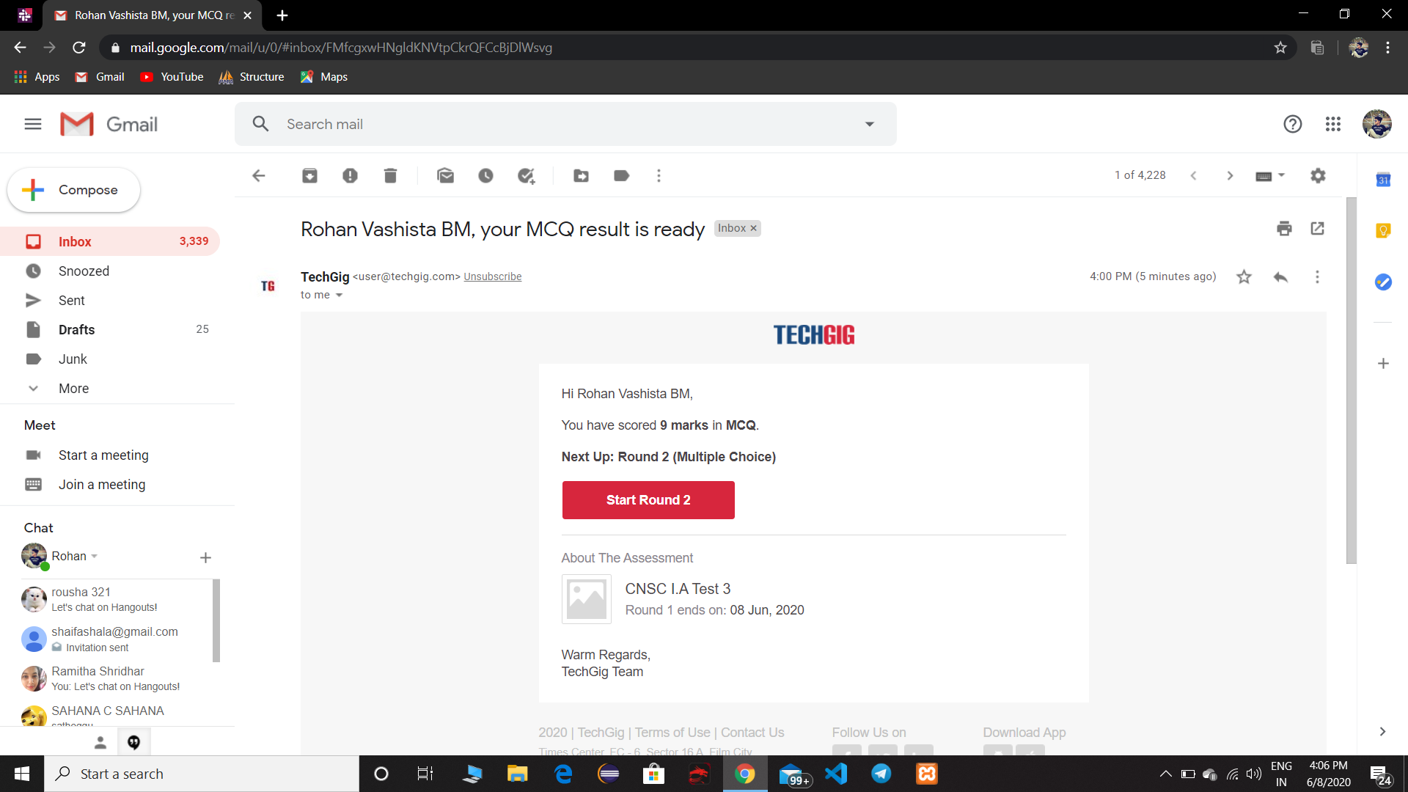

**Certification Details**

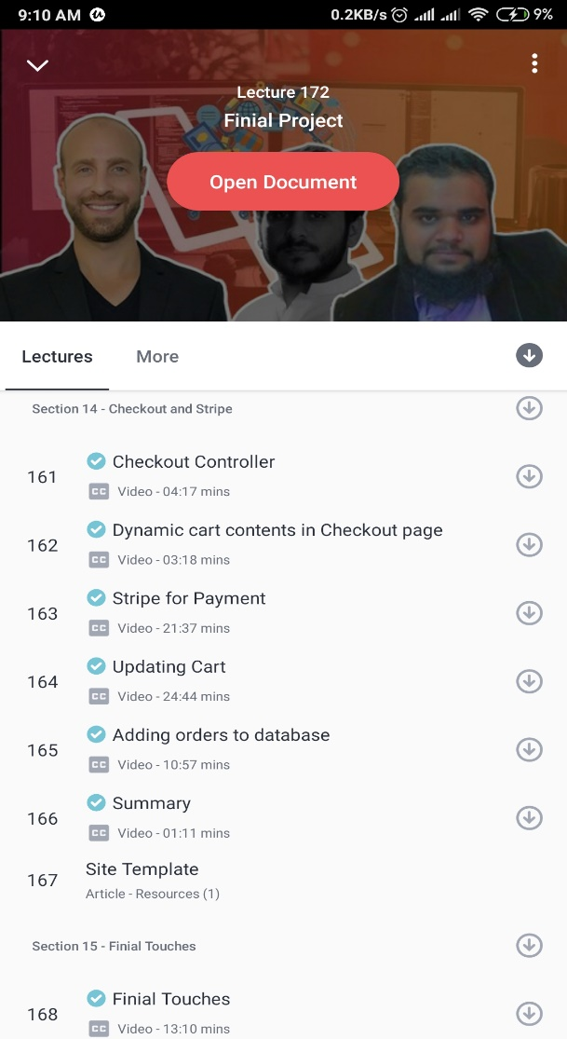 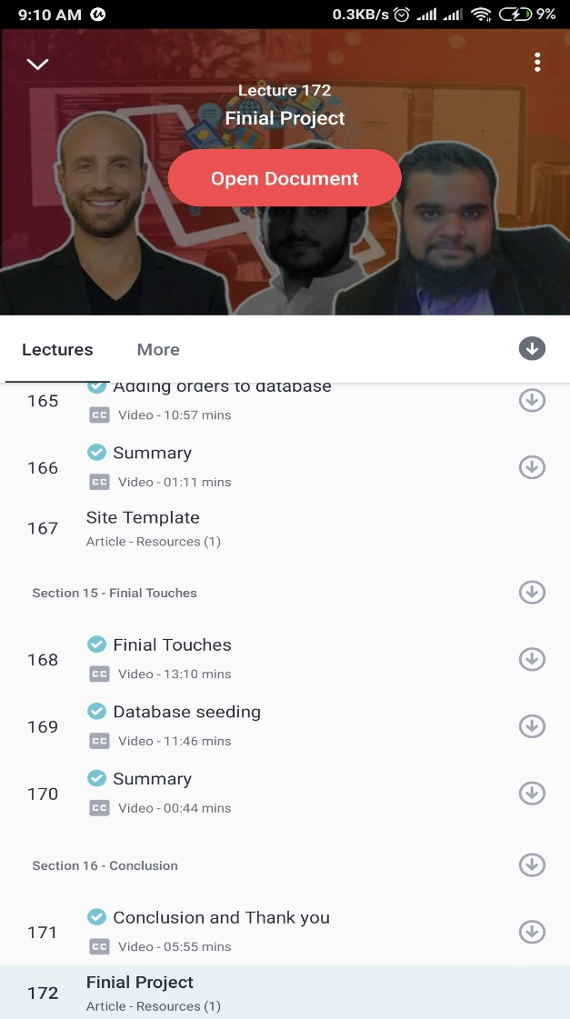

* Today I have completed concepts based on checkout and stripe finial touches and conclusion of this course.

**Coding Challenge Details**

1.Python Program to Copy the Contents of One File into Another

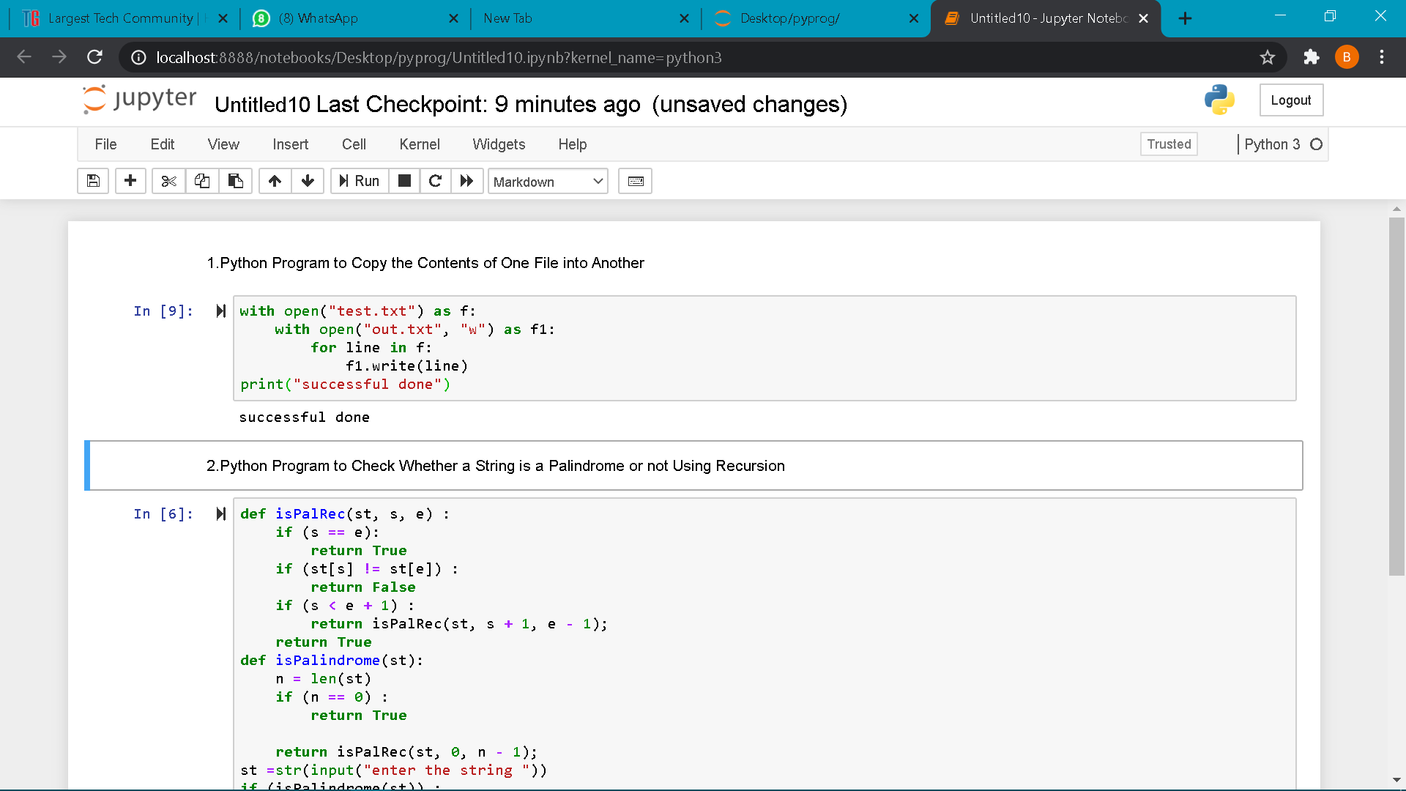

2.Python Program to Check Whether a String is a Palindrome or not Using Recursion



  
  
  
  
  